**Unit-1**

**Lecture 1.3**

**Multiple linear regression**

Multiple linear regression refers to a statistical technique that is used to predict the outcome of a variable based on the value of two or more variables. It is sometimes known simply as multiple regression, and it is an extension of linear regression.

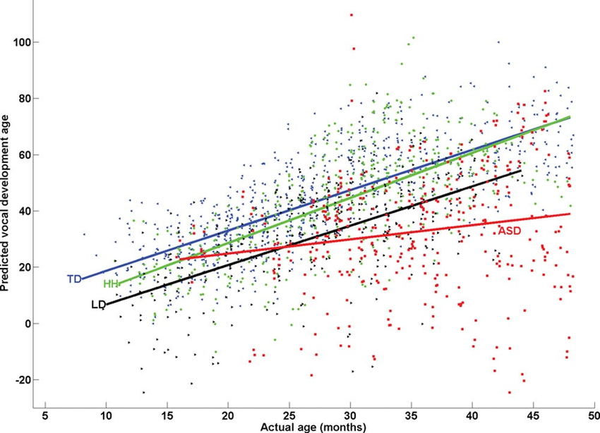Figure 1: Multiple linear regression model predictions for individual observations

**Multiple Linear Regression Formula**



Where:

* **yi​** is the dependent or predicted variable
* **β0** is the y-intercept, i.e., the value of y when both xi and x2 are 0.
* **β1** and **β2** are the regression coefficients representing the change in y relative to a one-unit change in **xi1** and **xi2**, respectively.
* **βp** is the slope coefficient for each independent variable
* **ϵ** is the model’s random error (residual) term.

**Understanding Multiple Linear Regression**

Simple linear regression enables statisticians to predict the value of one variable using the available information about another variable. Linear regression attempts to establish the relationship between the two variables along a straight line.

Multiple regression is a type of regression where the dependent variable shows a **linear** relationship with two or more independent variables. It can also be **non-linear.**

Both linear and non-linear regression track a particular response using two or more variables graphically. However, non-linear regression is usually difficult to execute since it is created from assumptions derived from trial and error.

**Book Reading and Video Material**

·        Understanding Machine Learning: From Theory to Algorithms by Shai Shalev-Shwartz and Shai Ben-David-Cambridge University Press 2014 [Download](https://www.cse.huji.ac.il/~shais/UnderstandingMachineLearning/understanding-machine-learning-theory-algorithms.pdf) Buy at Amazon

·        Introduction to Machine Learning – the Wikipedia guide [Download](http://datascienceassn.org/sites/default/files/Introduction%20to%20Machine%20Learning.pdf)

**Regression.pptx**